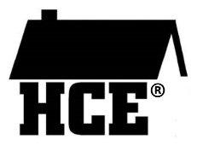

Wisconsin Association for Home and Community Education

HCE Members, Family, and Guest Speakers
Photo Release Permission Form

Please indicate whether or not you give permission to the Wisconsin Association for Home & Community Education (WAHCE) to use my your photo and comments in WAHCE reports, articles, and publications or on the WAHCE Facebook page or website designed for educational, informational, and promotional purposes. I understand some of these materials may be posted online for a period of time.

Cover Year – 2018-2019

Print Subject’s Name  (adult or youth) | Signature | Yes you may use my info or No you may not
 |  | Yes No
 |  | Yes No
 |  | Yes No
 |  | Yes No
 |  | Yes No
 |  | Yes No
 |  | Yes No
 |  | Yes No
 |  | Yes No
 |  | Yes No
 |  | Yes No
 |  | Yes No
 |  | Yes No
 |  | Yes No
 |  | Yes No
 |  | Yes No
 |  | Yes No
 |  | Yes No
 |  | Yes No
 |  | Yes No
 |  | Yes No

