FICO Score Pie Chart

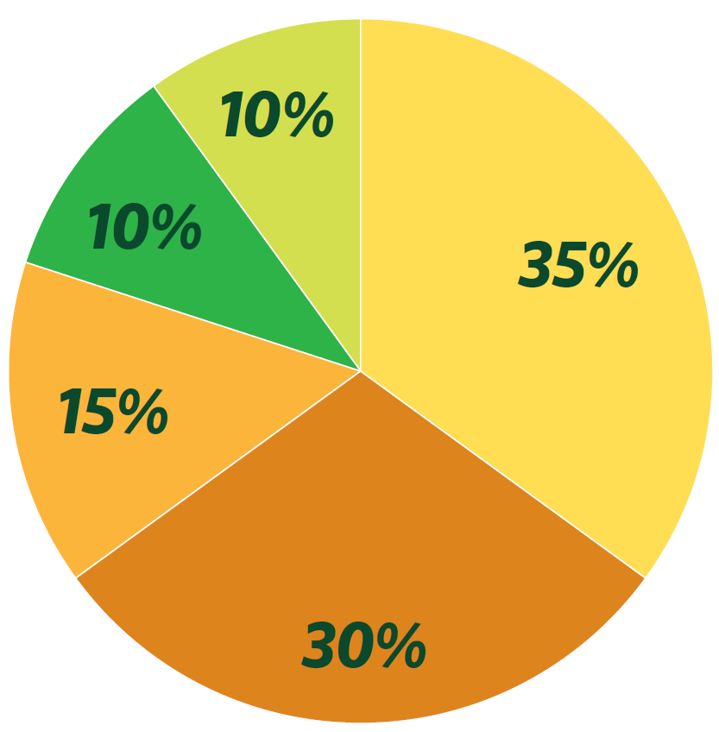

Instructions:
- Print the Pages - be sure to print them so they are NOT back to Back
- Cut Out the rectangle boxes.
- Optional: laminate they sheets and put velcro on them to make them stick.
- Ask participants to match the green category box with the corresponding the gold category definition box and then them on the pie square that they believe would reflect the percentage that piece of data would make up that their FICO score.

New Credit | Net Worth | Length of Credit History
Payment History | Amounts Owed | Types of Credit Used

Lenders want to know whether you pay your bills, so payment history is the biggest component of your score. If you have a strong overall credit history, one or two late payments may not hurt your score very much. Your score will increase if most of your accounts show that you have made all payments on time. | To figure out whether you might be over-extended, credit scores look at how much you owe, the number of accounts with balances, and how much of your available credit you are using. “Maxing out” your credit cards or having installment loans that you have paid little on can hurt your score. Your utilization ratio is the percent of your credit limit that you are using; a high ratio will hurt your score.
A FICO® score looks at how many new accounts you have, how many of your accounts are new, how long since you opened a new account, and how many inquiries there are on your credit history. | Having a mix of different types of credit accounts may help your score. Having only credit cards or finance company accounts can hurt. The types of credit you have may be more important if there isn’t much information in your credit history.
The higher your net worth is, the better because this demonstrates well money is managed overall. | The longer your credit history is, the better your FICO® score. But someone with a short credit history can still have a high score if the rest of their credit information is strong.

