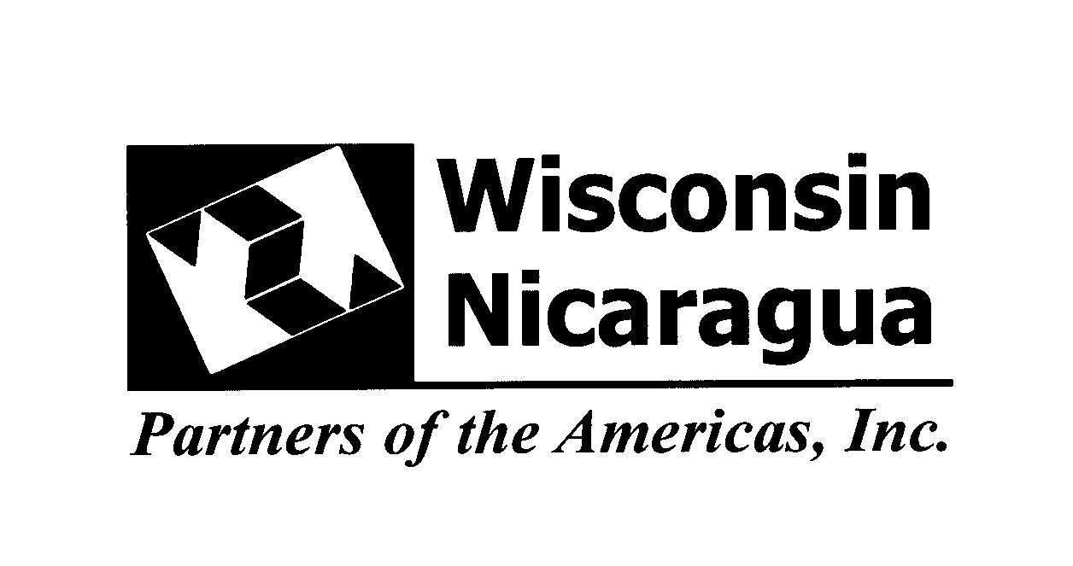

MATERIALS FOR THE WNP BAKING PROJECT

Along with the usual materials and supplies HCE has been so generous donating we are now asking for baking equipment
- Mixers
- Baking Pans: round, rectangular and sheet

Medium bowls
- Plastic rubber scrapers
- Metal spatulas
- Measuring cups and spoons
- Metal spatulas
- Cake icing bags
- Couplers and tips especially flower tips

Directions to warehouse
Hwy 51/39 north of Stevens Point, take the first exit (Casimir) turn east. Turn on North Second Drive, Drive North to the warehouse on the left.

Packing
Use paper copy boxes with lids if possible, smaller than 2 feet. Use the brown label as usual but clearly mark the box baking equipment. If you know the setup in the warehouse put a green office label on the box as well so some center that does only sewing and crafts won’t get the box,
Call the office to arrange a delivery time. (715-346-4702)

Numero: (#) | Wisconsin/Nicaragua Partners of the Americas  Compañeros de las Américas  Donación Humanitaria de los Compañeros de Wisconsin  para los Compañeros de Nicaragua
Destinatario: (To)  Learning Center  Centros de Aprendizaje |  | Denton Information:  From: Wisconsin/Nicaragua Partners of the Americas  Tel: 715-346-4702  Rm 134, Nelson Hall, UWSP  Stevens Point, WI 54481  U.S.A.  To: Compañeros de las  Americas Nicaragua/Wisconsin  Tel: 505-2-268-7586  Managua, Nicaragua  _________
Remitente: (From)
Wisconsin/Nicaragua Partners of the Americas

Contenida: (Contents)

Please print on tan or ivory paper

