25 YEARS OF FAITHFUL SERVICE

This Certificate Recognizes HCE Member

For 25 Years of Membership

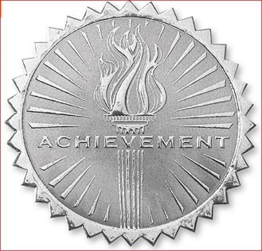

County President Signature Date

