50 Year Certificate
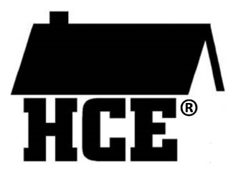
Presented to

For active service in the
Wisconsin Association for Home &
Community Education, Inc.

County President

Date County Secretary

