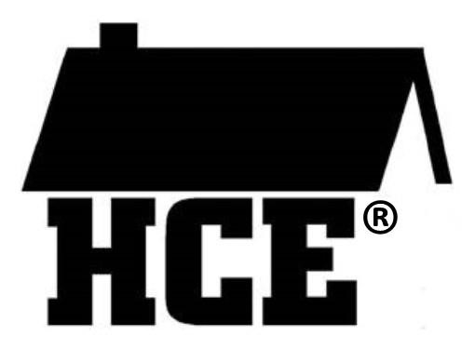
Columbia County Association for Home and Community Education Speaker Agreement Form

We‘re pleased that you will be doing a presentation for the Columbia County Association for Home and Community Education.

In order for us to prepare for the presentation, please complete this form and return it to your HCE contact person:

Click or tap here to enter text.
Click or tap here to enter text.
Click or tap here to enter text.

Date and location for your presentation: Click or tap here to enter text.

The topic for your presentation topic is: Click or tap here to enter text.

Your name as it should appear in our program: Click or tap here to enter text.

Your email address: Click or tap here to enter text.

The title you’ve chosen for your presentation: Click or tap here to enter text.

Two-three sentences that can be used to promote your presentation: Click or tap here to enter text.

Please indicate any audiovisual equipment that you will need us to provide: Click or tap here to enter text.

Do you require mileage reimbursement (at county rate)? ☐Yes --- number of miles: Click or tap here to enter text.
☐ No

Are there any other special arrangements or set-up you will need? If so, please describe: Click or tap here to enter text.

PLEASE TURN OVER

If you are able to bring handouts, please bring 50 copies. Some attendees will be taking information back to share with club members in their communities.

If you need us to do the copying you can send handouts by postal mail or e-mail, as long as they arrive a week before the engagement date.

We will not do a contract with you. However, submission of this Speaker Agreement Form implies your commitment to doing this presentation. If you are not able to do the presentation, please notify your HCE contact person as soon as possible.

Thank you again for agreeing to be with us. We look forward to meeting you!

