Welcome to

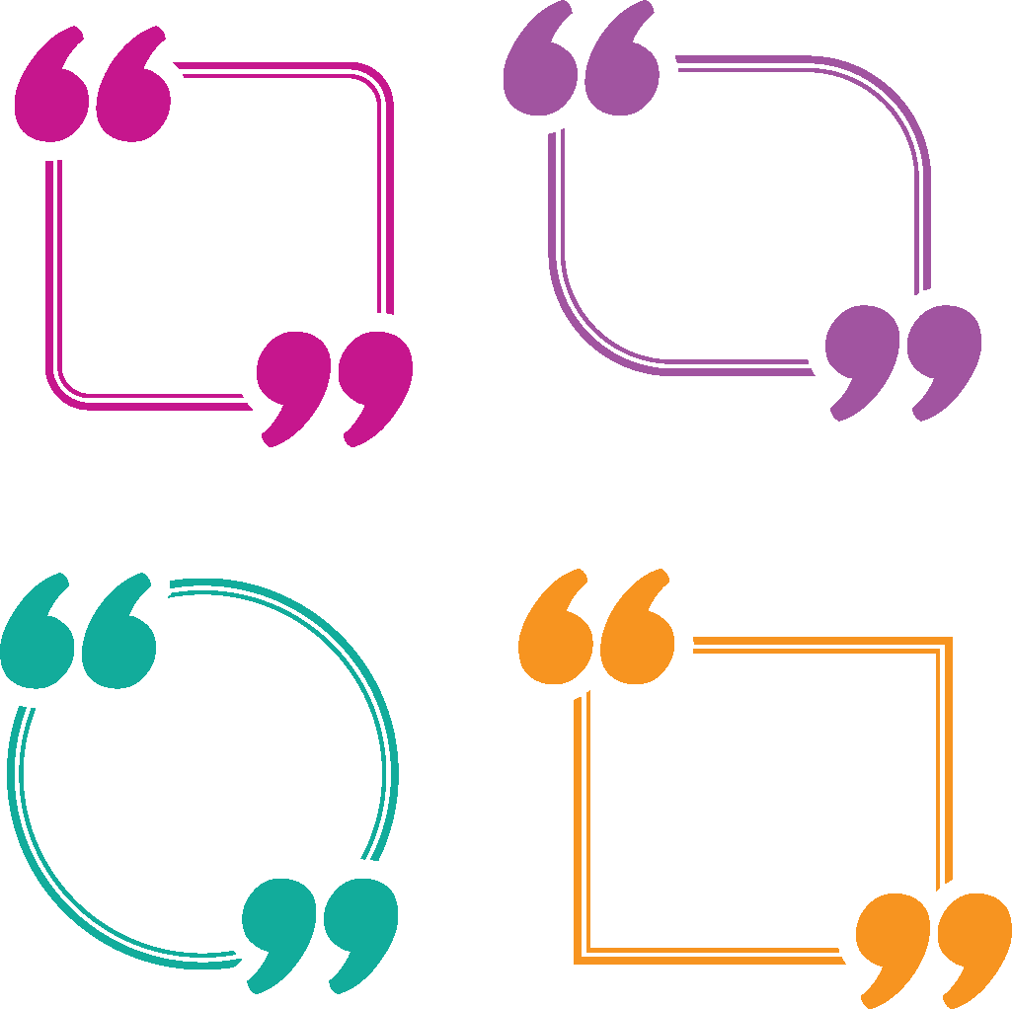

I value the friends that I have made in HCE; not only in my own club, but also at the county and state level.

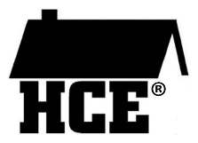_______ County HCE

__________ County Association for Home & Community Education (HCE) is a non-profit, educational, and charitable organization that offers its members opportunities to grow and learn.

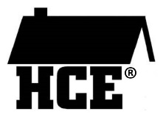Members meet monthly about nine times a year in each other’s homes during the day or evenings. Monthly educational lessons/programs are presented which club members are encouraged to attend and then shared at monthly club meetings.



In HCE, I’ve learned how to run a meeting and speak in front of people, something I haven’t done before joining my club.

Discrimination on the basis of age, race, color, creed or religion, national origin, ancestry, sex, sexual orientation, marital or parental status, pregnancy, veterans' status or qualified disability is prohibited.

A leadership role in our organization is not a requirement; only an opportunity. HCE affords members many opportunities for leadership development.

________ County

**~ Want To Know More? ~**

* about joining HCE
* about organizing a new HCE club
* about attending a monthly project
* about Wisconsin Bookworms

**Please contact**

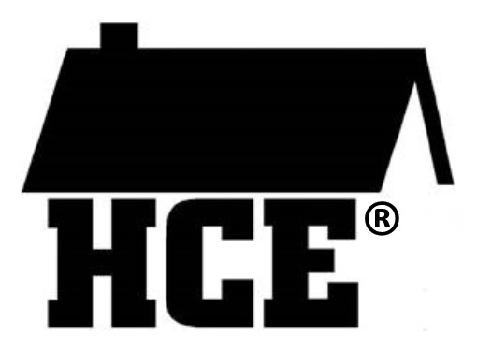Association for Home “  
 Community Education



*As a member of HCE, I’m always learning things that help my family*.

**Caring to make a difference in our homes, communities & world since 1940**



In partnership with University of Wisconsin Division of Extension

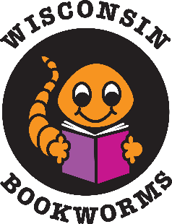



*Since I’ve joined HCE, I’ve learned so much from the educational programs*.

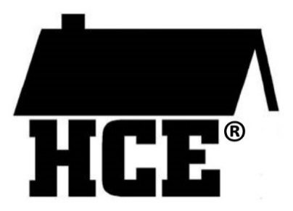

**The HCE Logo and What it Means**

The roof of the home symbolizes past heritage with Extension Homemakers.

The letters **H** (Home) **C** (Community)   
**E** (Education) make it a suitable logo for the state, county, and club.

The house without walls confirms a commitment to membership – open to all regardless of race, color, creed, religion, sex, age, handicap, or national origin.

**Mission Statement for the Wisconsin Association of Home and Community Education, Inc.**

**HCE Offers Opportunities for:**

* Learning in a social setting
* Sharing what we learn
* Caring to make a difference in our homes, communities, and the world

**WAHCE VALUES:**

* Families and communities
* Opportunities for personal growth through learning, sharing, volunteering
* Meeting great people and forming friendships
* Volunteering to make a difference
* Leadership

**Wisconsin Association for Home and Community Education**

[www.wahceinc.org/](http://www.wahceinc.org/)

[www.facebook.com/WAHCEinc/](http://www.facebook.com/WAHCEinc/)

**Affiliated with:**

Associated County Women of the World (ACWW) [www.acww.org.uk/](http://www.acww.org.uk/)

Country Women’s Council USA (CWC) [www.cwcusa.org/](http://www.cwcusa.org/)

National Volunteer Outreach Network (NVON) www.nvon.org/**Wisconsin Bookworms**

Wisconsin Bookworms is a reading program designed to help young children develop a life-long love of reading.

Children ages 3-5 enrolled in ___________________ are visited monthly by volunteer readers who:

* Read a “book of the month”
* Do an activity pertaining to the story
* Give each child a copy of the book to take home



*The Wisconsin Bookworms program is such a rewarding project. The children we read   
to are always eager to hear the story and receive a copy of the book to take home.*

By the end of the school year, ___ children receive a set of 8 FREE books to create their own homelibrary**.**

**Caring to make a difference in our homes, communities & world since 1940**