Welcome to the Meeting!!!

10:00 am Registration & Morning Refreshment - fruit, sweet breads, coffee, and juice.
10:30 am - 12:00 pm Welcome and Business Meeting
Agenda to Follow
Noon Lunch - Catering by Bryan - sandwiches, salad/relishes, dessert bars
1:00 pm Speakers: “The Bend Theater: History & Restoration Efforts”
Bill Buettner, Executive Director; Megan Cox Events Director

Learn of the history and restoration of The Bend Theater. This theater has been part of the West Bend community and surrounding areas since 1929.

Registration Fee: $20 per person Deadline for Registration: April 5, 2024


Registration Deadline: April 5, 2024

SE District Spring Meeting - April 17, 2024
Jackson Community Center - N165 W20330 Hickory Lane, Jackson WI 53037
(hosted by Washington County)

County: _____________________________ Phone: _____________________________
President: ___________________________ Total Amount $ ______________________
******************************************************************************************* _____________________________ ___________________________
_____________________________ ___________________________
_____________________________ ___________________________
_____________________________ ___________________________
_____________________________ ___________________________
_____________________________ ___________________________
_____________________________ ___________________________
_____________________________ ___________________________

Please mail $20.00 per person at the bottom of the form to:
Make checks payable to: Washington County HCE

WCHCE Treasurer: Faye Schneider - 4698 Pioneer Rd., Richfield, WI 53076

Directions to the Jackson Community Center
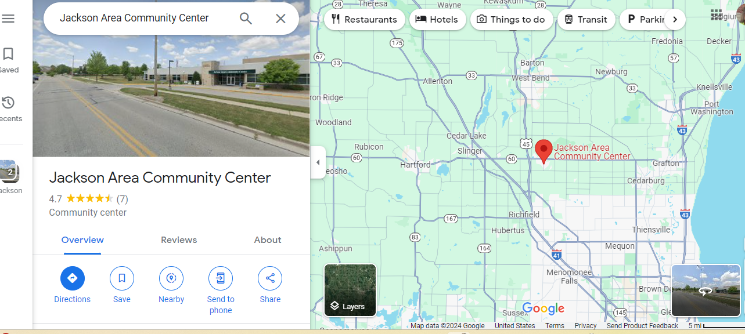

Jackson Community Center Detour Instructions -
East - approaching from the east on 60 you need to take Hwy G (Division road) south to Sherman (west) and then north on Jackson Dr to Hickory Lane.

North - Coming from Hwy 45 Hwy 60 exit) you need to head east on 60 and then south on to Hwy P to Sherman (east). Turn north to Jackson Dr. to Hickory Lane.

South - Coming from the South, take the Hwy 145 exit (east) then north on Hwy P to Sherman (east) then north on Jackson Dr.

Watch for detour signs to be posted.


WAHCE Facebook:

https://www.facebook.com/WashCoHCE

