Welcome to

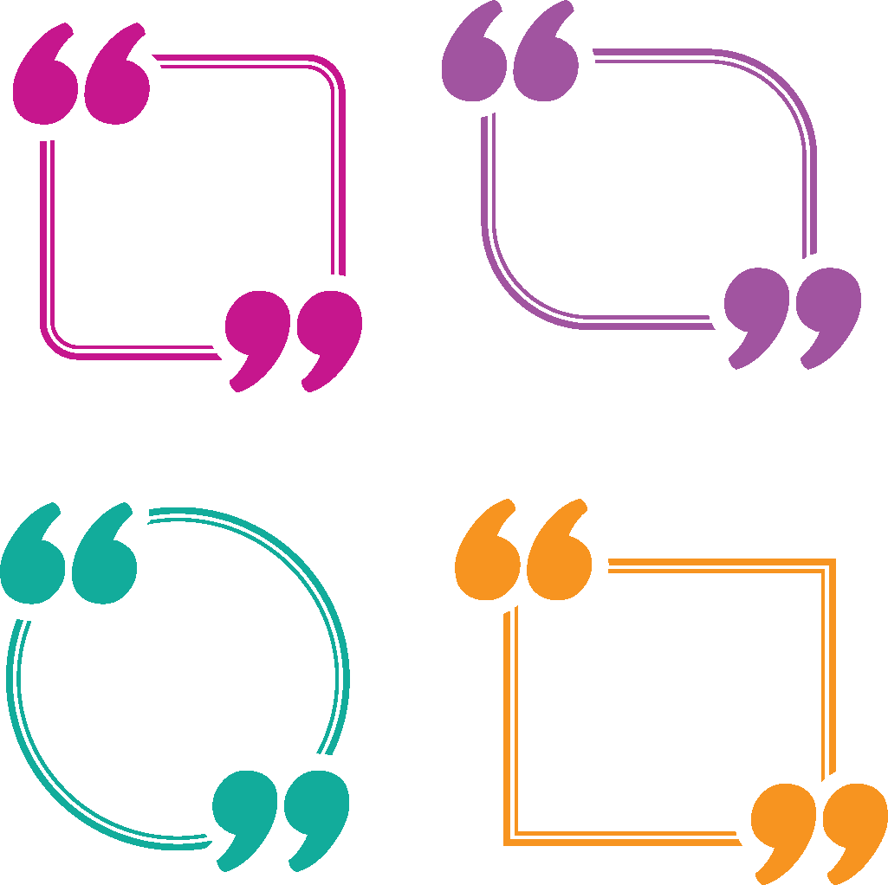

*I value the friends that I have made in HCE, not only in my own club, but also at the county and state level.*

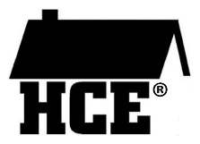Jackson County HCE

Jackson County Association for Home & Community Education (HCE) is a non-profit, educational, and charitable organization that offers its members opportunities to grow and learn.

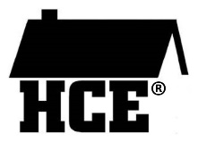Members meet monthly about nine times a year in each other’s homes, restaurants, or other locations during the day or evenings. Monthly educational lessons or programs are presented which club members are encouraged to attend.



*In HCE, I’ve learned how to run a meeting and speak in front of people, something I haven’t done before joining my club*.

Discrimination on the basis of age, race, color, creed or religion, national origin, ancestry, sex, sexual orientation, marital or parental status, pregnancy, veterans' status or qualified disability is prohibited.

A leadership role in our organization is not a requirement, only an opportunity. HCE affords members many opportunities for leadership development.

Jackson County

**~ Want To Know More? ~**

* about joining HCE
* about organizing a new HCE club
* about attending a monthly meeting
* about Wisconsin Bookworms

**Please contact:**

**Membership Chair**

**Rita Meyers – 715-333-2222**

**Or Jackson County President**

**Cheryl Gabrielson – 715-299-2380**

Association for

Home &

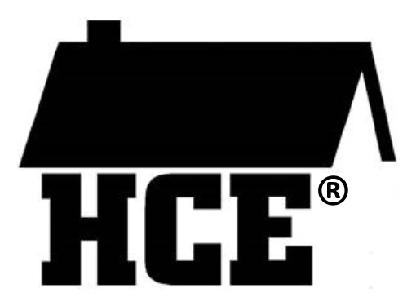Community Education



*As a member of HCE, I’m always learning things that help my family*.

**Caring to make a difference in our homes, communities & world since 1940**

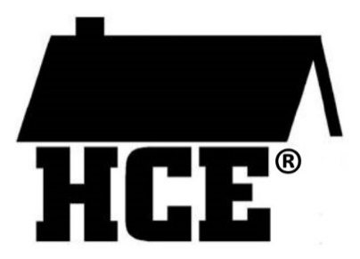

**The HCE Logo and What it Means**

The roof of the home symbolizes past heritage with Extension Homemakers.

The letters **H** (Home) **C** (Community)   
**E** (Education) make it a suitable logo for the state, county, and club.

The house without walls confirms a commitment to membership – open to all regardless of race, color, creed, religion, sex, age, handicap, or national origin.

**WAHCE VALUES:**

* Families and communities
* Opportunities for personal growth through learning, sharing, & volunteering
* Meeting great people and forming friendships
* Volunteering to make a difference
* Leadership

**Jackson County HCE Annual Dues are $20.00.**

**We invite you to join us.**

**Wisconsin Association for**

**Home and Community Education**

[www.wahceinc.org/](http://www.wahceinc.org/)

**Your Membership Entitles**

**You To:**

•  A quarterly newsletter—**HORIZON**

• Educational materials and workshops

• Membership in State and Local Association

• New Friendships & Opportunities

• Belonging to one of our 7 clubs

Our Community Projects

• Wisconsin Bookworms Reading Program

• Education Scholarships

• Pennies for Friendship International & local

• Bibs and Books to new babies at Black River Memorial Hospital & Footprints in Time

• Partnership with Wisconsin/ Nicaragua learning centers

Our Celebrations

• Spring meeting with Cultural Arts Competition

• Fall Awards Banquet

• HCE Week (First full week in November)

• Christmas Party with White Elephant Auction



Wisconsin Bookworms is a reading program designed to help young children develop a life-long love of reading.

Children ages 3-5 enrolled in Head Start are visited monthly by volunteer readers who:

* Read a “book of the month”
* Do an activity pertaining to the story

• Give each child a copy of the book to

take home. By the end of the school

year, children receive a set of 7 FREE books to create their own homelibrary**.**

**Caring to make a difference in our homes, communities & world since 1940**

*The Wisconsin Bookworms program is such a rewarding project. The children we read   
to are always eager to hear the story and receive a copy of the book to take home.*



**Caring to make a difference in our homes, communities & world since 1940**