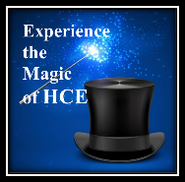
2024 WAHCE Annual Business Meeting and Conference Tours
Tours will be Monday September 16, 2024. All tours will leave the hotel at 12:00 noon and return by 4:00pm. Tours will be transferable but not refundable. If a tour is cancelled, guests will receive their next choice. All tours have a minimum of 40 and maximum of 54 guests.

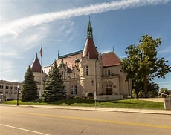
Tour #1 -- History Museum at “The Castle” and School Bus
Tour of Appleton $30.00
Experience the magic of Harry Houdini! Get an inside look at the world-renowned magician who lived in Appleton for four years as a child. This exhibit takes visitors through his childhood, early career, rise to fame, and legacy with photos, video, and artifacts used by the man himself. From local history to Houdini, the exhibits offer a glimpse into life in Appleton and the Fox Cities. Followed by a “school bus tour” of the Appleton area which highlights the city’s rich history and scenic areas.

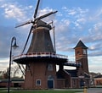
Tour #2 -- Little Chute Windmill and Kerrigan Brothers Winery $30.00
Enjoy a short school bus ride to the Little Chute Windmill, an authentic, fully functioning 1850’s design from the Netherlands, standing over 100 feet tall. It is a tribute to the Dutch heritage of the Midwest and bears witness to the history of Dutch migration and settlement in the region. The visitor center features a museum, gift shop, meeting rooms, media room, and archival storage.
Next we travel to the Kerrigan Brothers Winery, a family owned and operated business since 2000. Learn about their history, wine making process, and special wines. Enjoy wine tasting and browse through their fabulous gift area that includes wines and unique gift items.

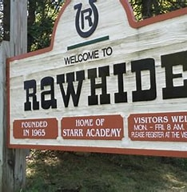
Tour #3 -- Rawhide Youth Services, New London $40.00

A couple with a dream. A star quarterback with a heart for changing lives. Since 1965, RAWHIDE has carried on the legacy of hope that the Gillespie and Starr families first brought to life. Founded on compassion and continuing a legacy of transformation. Tour includes a 30+ minute motor coach ride to the Ranch and back, visit the Welcome Center, tour the grounds, and have a special dessert and coffee in the cafeteria. A very inspirational afternoon. Minimum amount of walking.
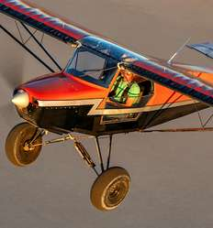
Tour #4 -- EAA AirVenture Museum, Oshkosh $40.00
Walk through Aviation’s history! Discover airplanes used in aviation’s early days and a tribute to the Wright brothers. Explore World War II aviation. Throughout the museum, there are historic photographs and works of art. A gift shop is available. All areas of the museum are wheelchair accessible via ramps and elevators. Free wheelchairs are available for visitor’s use. Tour includes a 30 minute motor coach ride to the EAA.
Not going on a tour? Try these at the Hotel at 1:00 pm:
- A: Fox Trot Trail Self Guided Tour (no charge)
For those who like walking, the Fox Trot Trail offers the perfect way to spend an afternoon. The Trail takes visitors on a self-guided tour of the most important Appleton landmarks, covering a total of 2.2 miles s. There are 16 stops in total, enabling you to learn about places such as Houdini’s childhood home, and the world’s first hydro-electric power plant. The Trail is easy to find: just follow the BLUE FOX PAWPRINTS on the sidewalks, from one stop to the next.
- B: Water Exercise at the Hilton Appleton Paper Valley Pool (no charge) -- Join HCE Members as Charlotte DuPree leads them in water exercise.
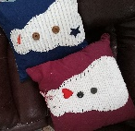
- C: Card Making with Pam Fiedler -- All supplies are provided for you to make four greeting cards including envelopes. $15 supply fee paid directly to Pam. Limit of 20
- D: Funky Snowman with Lynn Marcks -- Join Lynn in creating the Funky Snowman pillow
an easy, fun, you can't go wrong sewing project. Bring a 16 X 16 sofa pillow in a dark plain color and a scissors. Fee for supplies is $25 paid directly to Lynn at the workshop. Limit of 18
- E: Paper Crafts with Althea and Amanda Smith -- Make several different paper crafts: an apple with a roll of toilet paper, paper bag star, and a scrap book to hole memories of conference. Bring scissors if you have them. $18 fee paid to Althea at workshop.

