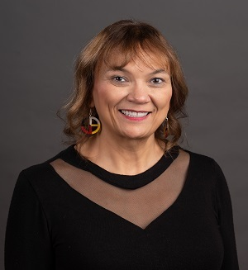
Keynote Speaker: Dr. Annie Jones
“The Magic of Leadership” is the topic of Dr. Annie Jones keynote address on Monday, September 16, at our opening banquet. Annie is a Professor for Organizational Development and a Tribal Nations Specialist with the University of Wisconsin Madison, Division of Extension.
Annie has worked with Extension for twenty years serving in a variety of capacities including Associate Dean, Special Assistant to the Dean for Strategic Directions and a county-based Community Development Educator.
Annie's areas of research include indigenous methodologies like the use of the Native American medicine wheel and cultural teachings to enhance planning and evaluation. Annie specializes in participatory and community-based action research.
Annie has a Doctoral Degree, in Human and Organizational Systems, University Master of Arts, Human Development, Fielding Graduate University as well as a Graduate Certificate, Dialogue, Deliberation and Public Engagement, Fielding Graduate University
Her Master of Science degree is in Curriculum and Instruction-Technology Enhanced Education, UW Whitewater. She also has a Bachelor of Arts, Geography and Social Science with an emphasis in History, Carthage College.

Inga Witcher, Tuesday Evening Speaker
A passionate dairy farmer, Inga Witscher and her husband Chance own and operate a small organic dairy farm near Osseo, Wisconsin. When she's not setting up pastures for their cows to graze, milking the 8 Jerseys, making cheese with her father, or indulging her passions for gardening and cooking, Inga turns her attention to collaborating on narratives for the pbs program Around the Farm Table .
After growing up on her family's dairy farm on the West Coast, she's proud to call Wisconsin home where there are truly happy cows, and a vibrant agriculturist, all of which she loves to celebrate on Around the Farm Table.

