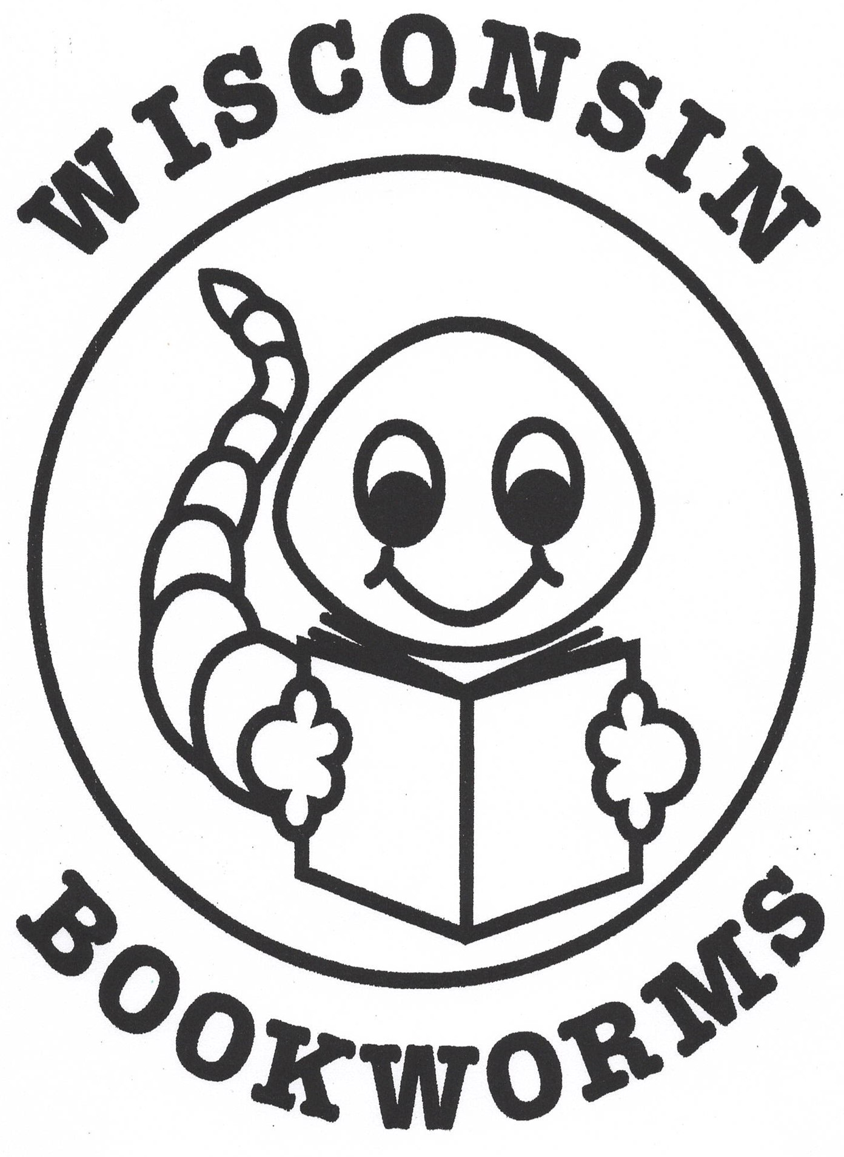
Celebrating 25 Years!!

Wisconsin Bookworms is designed to help preschool children develop a love of reading. Volunteers read to children on a monthly basis, engage them in the book, and give them a free copy of the book to take home to create their own “in-home” library.
This reading program is sponsored by
Wisconsin Association for Home and Community Education

