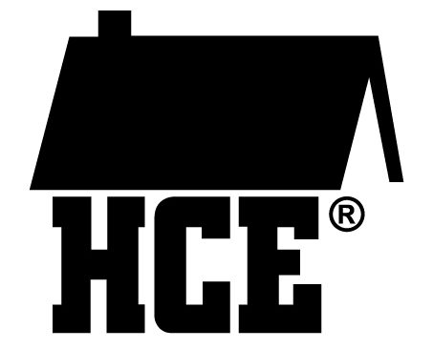
Columbia County Association for
Home and Community Education
Speaker Agreement 2025

We are pleased that you will be doing a presentation for the Columbia County Association and Community Education.

To help us prepare for your presentation, please complete this form and return it to your
HCE contact person: Donna Kohnke kohnkedonna@gmail.com

Date and location for your presentation:

The topic of your presentation is:

Your name as it should appear in our program:

The title of your presentation:

Your email and phone number:

Two to three sentences that can be used to promote your presentation:

Are there any other special arrangements or technical set-up you will need for your presentation? If so, describe:

Do you require mileage reimbursement (at county rate)?
Yes ___ No ___ Number of miles ______

Technology needs: (The brand name of the computer or I-Pad you will be using so we can have the correct connection cords available, unless you are bringing your own HDMI cord, etc.)

PLEASE TURN OVER

If you are bringing handouts, please bring 50 copies. Some attendees will be taking information back to share with club members in their communities.

If you need us to do the copying, you can send handouts by email or postal mail as long as they arrive a week before the presentation date.

We will not make contact with you prior to the presentation. However, submission of this Speaker Agreement Form implies your commitment to your presentation. If you are not able to do the presentation, please notify your HCE contact person as soon as possible.

Thank you again for agreeing to be with us. We look forward to meeting you!

I grant Columbia County Association for Home and Community
Education (CCAHCE) the right to use, publish, and copyright my image for Education programs and publications, web sites and promotion of Wisconsin Association for Home and Community Education, Inc. (WAHCE)
programs.

_____________________________ __________________________
Signature Print Signature

Date__________________

