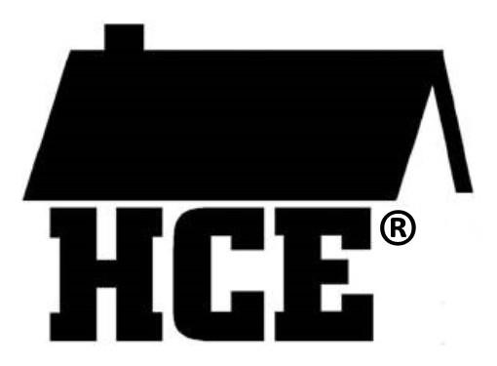

Wisconsin Association for Home and Community Education

HCE Members and family, Guest Speakers Photo Release Permission Form

___ I grant permission to the Wisconsin Association for Home & Community Education (WAHCE) to use my photo and comments in WAHCE reports, articles, and publications designed for educational, informational, and promotional purposes. I understand some of these materials may be posted online for a period of time.

___ I grant permission to the Wisconsin Association for Home & Community Education (WAHCE) to use the photo and comments of my minor child, (name) _____________________, in WAHCE reports, articles, and publications designed for educational, informational, and promotional purposes. I understand some of these materials may be posted online for a period of time.

Cover Year – 2026

Print Subject’s Name (adult or youth)
Signature
Date:
Print Name of Parent or Guardian: | (Parent or guardian must sign if subject is under age 18
Address
City/State/Zip
Telephone
Email:

Comments:

Please Note: All members need to sign either the new membership roll sheet or this photo release. This document needs to be with your County HCE records and readily available upon request. Conference Chairs and other special events chairs – should maintain a copy respectively.

Rev.12/28/2025

