9:00 to 10:30
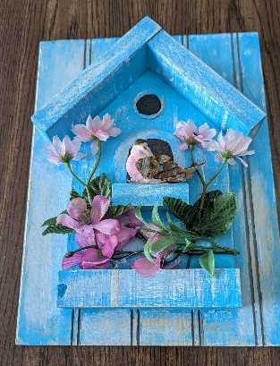
Birdhouse
Paint a decorative birdhouse for a spring decoration.
Instructor:
Lou Ann Muranyi

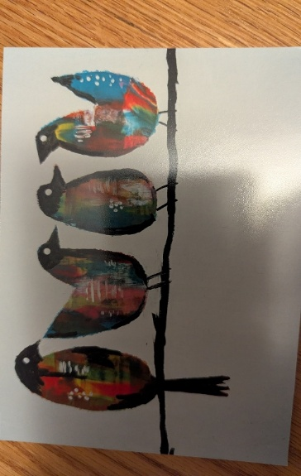

Pull Painting with birds
Beginner project with great results.
Instructor: Nancy Borchardt

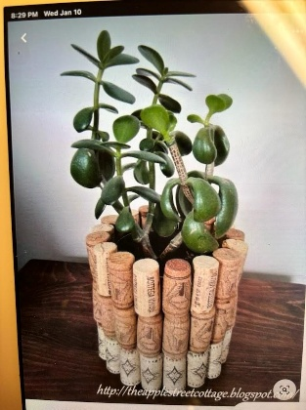
Cork Vase
Use corks to cover a glass vase and make a decorative plant holder.
Instructor: Beth Bartelt

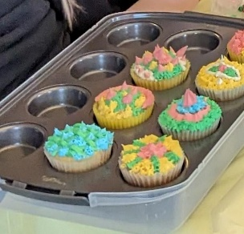
Cupcakes
You will use spring colors to decorate cupcakes. Various frosting tips will be available, including rose tips.
Instructor: Connie Nowak

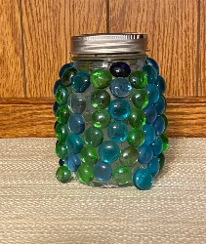
Solar Light
Create a solar light with fairy lights and glass beads.
Instructor: Diane Durst

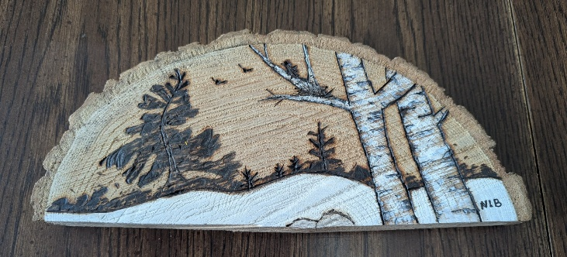
Woodburning
Use a wood burner to create designs on a wooden disk. You can do basic woodburning or woodburning with painted features.
Instructors: Karen Martinson and
Mae Dombrowski

10:45 to 12:15
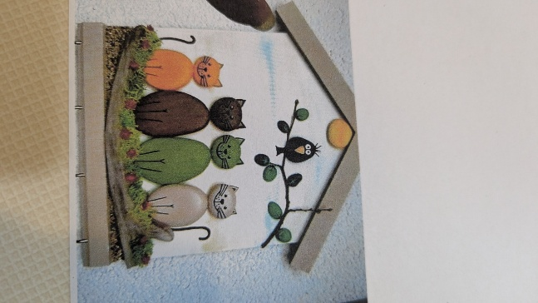
Rock Art Cats
Paint rocks as cats to be mounted on a wooden plaque for a 3D effect.
Instructor:
LouAnn Muranyi

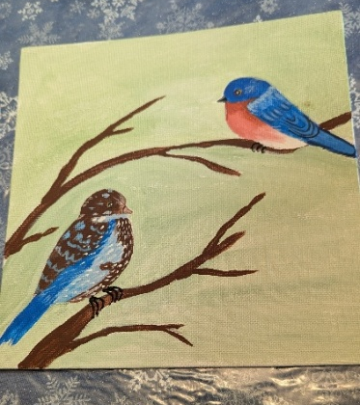
Acrylic Painting
You will be given an 8X10 canvas and be guided in using acrylic paints to paint blue-birds.
Instructor: Barb Gwidt

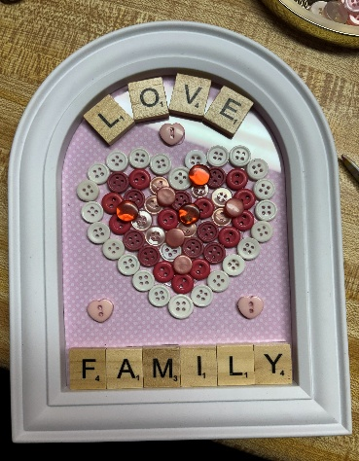
Framed Button Art Use buttons to make a beautiful decoration.
Instructor:
Beth Bartelt

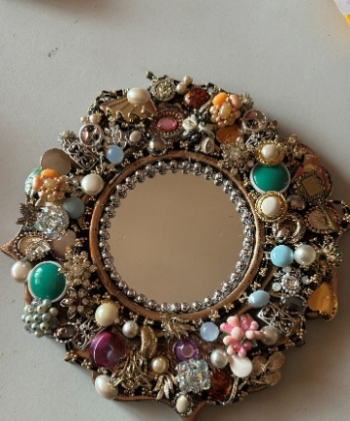
Jeweled Mirror
Use jewelry to cover the frame on a mirror.
Instructor:
Sue Krueger

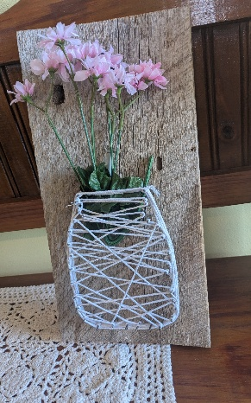
String art
Make a lovely wall decoration, creating a string art vase.
Instructor: Sue Jung

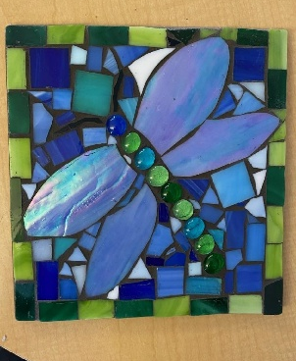
Mosaic – Part 1 and Part 2.
You will be making a mosaic using stained glass. Design choices may be a dragonfly, sunflower or a cardinal. The class will cover techniques in preparing the substrate, setting pieces and grouting the mosaic. You will take home a complete mosaic.
NOTE: An additional $15 will be collected by the instructor for materials. Classes may run overtime.
Instructor: Yvette Huesler

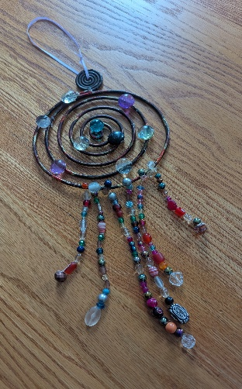
Suncatcher
Using a variety of beads, you will string them on fishing line and attach them to a metal disc.
Instructor: Linda Krenz

1:00 to 3:00

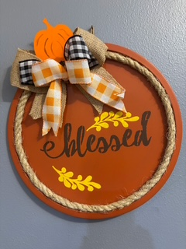
Pizza Pan wall decoration
Create a beautiful summer decoration using a pizza pan, ribbon and flowers. Picture shown is a fall decoration, but summer colors will be used.
Instructor: Diane Durst

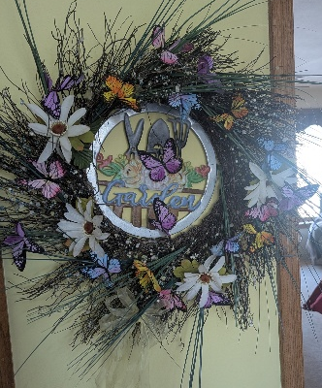
Butterfly Wreath
Create a stunning wreath using natural materials for the base and a variety of flowers and butterflies to complete the project.
Instructor:
Nancy Borchardt

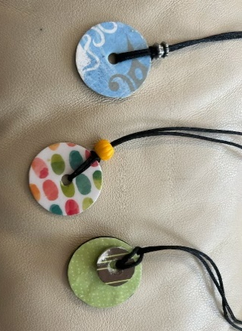
Darling Disc Necklace
You will use beautiful decorative papers, a washer and decoupage to create a one-of-a-kind necklace.
Instructor:
Diane Arneson

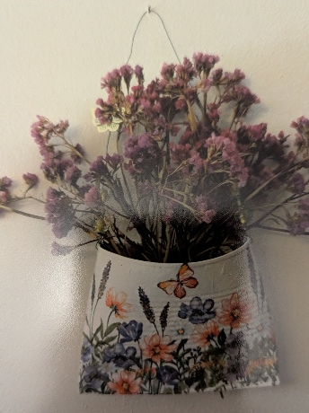
Decoupage
Create a metal wall hanger with decorative decoupage design, beads and flowers.
Instructor:
Marlene Kloth

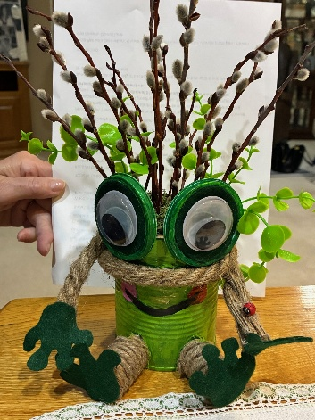
Frog Centerpiece
Create a delightful table centerpiece that will be just right for spring.
Instructor: Sue Jung

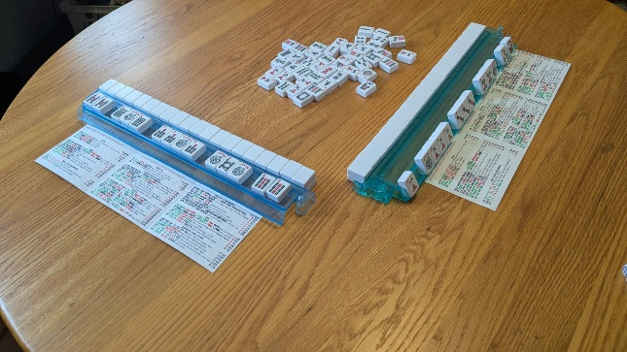

Introduction to Mahjongg
Using skill, strategy, and luck, make a winning hand of 14 tiles. We will practice using a set of 144 tiles, and the official 2025 Mahjongg card.
Instructor: Linda Krenz

