2026 KCAHCE Community Service Project… Supporting Fostering in Kenosha
Two Kenosha organizations have been selected for the 2026 Community Service Projects; 1 Hope and the Fostering Closet Kenosha. Collection locations and times will be communicated once determined. Questions should be addressed to Margaret McCabe of Good Neighbors (Community Service Committee) at (262)857-9115 or via email of mm00004@aol.com .

1HOPE brings the community together to support foster families!
5900 77th St. , Kenosha, WI, United States, 53142 info@1hope.community
Who We Are
1HOPE exists to love, strengthen and support our local foster families. Through intentional relationships, impactful events, and practical resources, we create opportunities to strengthen the foster family community and provide a foundation of love, hope and healing. Our mission is to ensure that no child or family walks this journey alone.
Kenosha Foster Care
Kenosha is facing a critical shortage of foster families. Hundreds of kids in need of a safe home are being sent to other cities because there simply aren’t enough local families to care for them. These children deserve to stay in their community, but we need more families to step up. Foster families need support, and that’s where we come in.
Providing Foster Family Support…
The mission of 1HOPE’s Foster Family Support Network (FFSN) is to ensure that every foster family is receiving enough support, love, and encouragement throughout their foster care journey. Our heart is for not only for foster children but for the entire family. Through our FFSN, we help foster families meet their day-to-day needs as they open their hearts and homes to some of the most vulnerable children in our city. Support from our network helps reduce the stress foster families face while providing a better experience and outcome for the foster child placed in their care. These positive experiences not only increase the number of foster homes the re-license but also increase the number of new homes licensed. New families are aware that if they become a foster home in Kenosha County, the FFSN will be there to support them.
Wrap around a family
Are you interested in working directly with a foster family? Do you want to build life-giving relationships and have a lasting impact on these children and parents? If so, this is the option for you. As a family volunteer, you will commit to blessing a foster family one time every month. What does this look like? Well, it depends on how you would like to serve! We will match you with a family that wants to receive what you are willing to give. Blessings typically include bringing a meal, random acts of kindness, babysitting, mentorship, gift cards, gas cards, or anything to make life a little easier and the families to know that they are not alone!
Family Nights at the 1HOPE Community Center
Our family nights are held once a month, and this is a time where our foster families can come pick up their diapers and other blessings that are donated to us through Amazon and the community. It is a fun-filled night for our families to come together, connect with one another, and grow in fellowship!

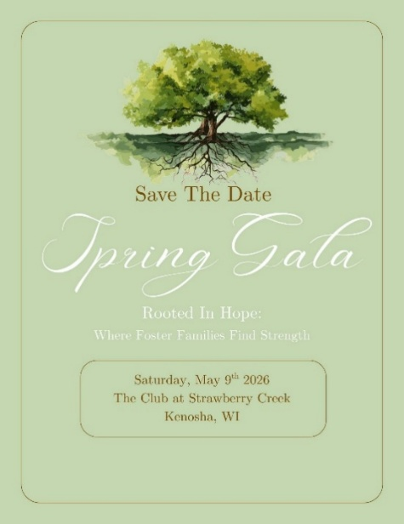
Spring Gala (Annual Fundraising Event)
This special night will be filled with hope, community, and stories that reflect the heart of 1HOPE and the impact made possible because of friends like you.
More details, including ticket information, sponsorship opportunities, and event highlights—will be shared soon. For now, we hope you will place this date on your calendar and plan to attend.

Ways KCAHCE Members and Clubs can help:
Purchase Products to donate: Baby wipes and socks for all ages of kiddos! These items are always needed!
Note: They purchase diapers in bulk at great prices, so monetary donations are greatly appreciated to support those purchases!
Provide Financial Support; cash donations, gift cards, gas cards, as often, last minute needs arise when a new child comes into the program. Even $5 Walmart cards or Target cards help tremendously.
Donate Raffle items and or baskets for their Spring Gala (in May). Ideally baskets for their silent auction average $30-$50 value. If gift cards are donated for this event, they will build baskets accordingly. Have a restaurant gift card you might not be using?
Clubs who decide to do donations for the Gala, should contact Margaret for pickup or drop-off of items.
General Info…
Summer will bring a “Back to School” collection, once specifics are received for that program – the Community Service Committee will communicate their needs.
Open invitation - Would you like to attend one of their Family nights to see how wonderful the evenings are for the Families? Or even consider volunteering to help at one of their Family nights? Information can be found on their website (shown above) or by calling (262)764-0055 to inquire.
The Foster Closet (Kenosha)
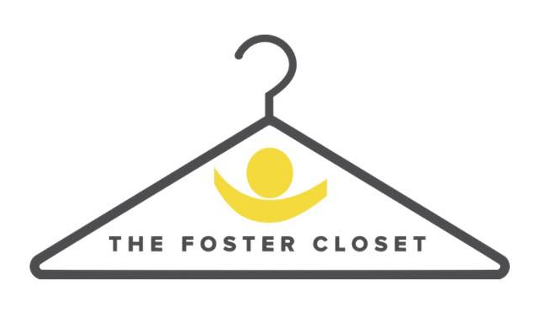
13022 Wilmot Rd, Kenosha, WI, United States, 53142
fosterclosetkenosha@gmail.com

The Foster Closet is a ministry of First Christian Church, dedicated to serving foster families during times of transition. We provide a week's worth of clothing, hygiene items, and essentials to ease the load and help kids cared for and welcomed.
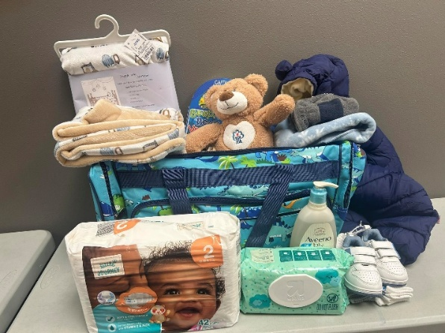
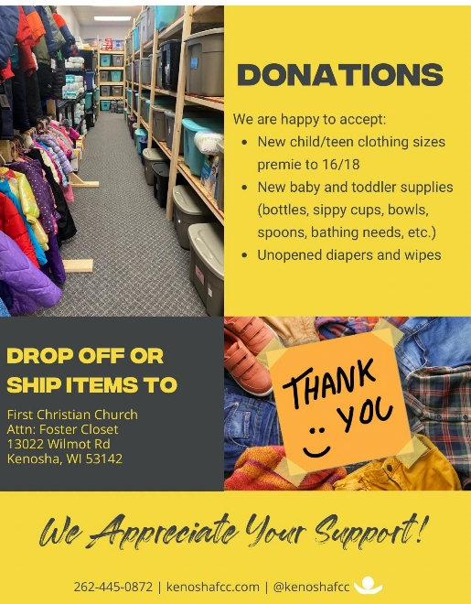

Above is a Bag packed for a little one who came into foster care with very little. Typically, they provide a duffel bag with about one week of clothing, shoes, jacket, hat, mittens/gloves, a blanket and an age-appropriate book or coloring book and crayons.
Ways KCAHCE Members and Clubs can help:
Purchase Products to donate: Hygiene items, unopened diapers and wipes, as well as personal items like body soap, shampoo, conditioner, lotion, toothpaste, and toothbrushes. New books, coloring books and crayons, and blankets. New baby and toddler supplies (bottles, sippy cups, bowls, spoons, bathing needs, etc.). New baby and toddler supplies (bottles, sippy cups, bowls, spoons, bathing needs, etc.).
Purchase Clothing and Such: New child/teen clothing sizes preemie to 16/18. Items /include pants, shorts, t-shirts, both long and short sleeve, pajamas, underwear, socks, shoes, boots, jackets and sweaters.
Or…. Donate items and or baskets for their Foster Parent Appreciation Banquet! (in May).
Info regarding their event from their Facebook page: Let's Celebrate Our Foster Parents
Foster Parent Appreciation Month is in May…
Foster Parents make our community better by caring for Kenosha’s children. Let’s show them how much we appreciate their help by donating a gift basket or item to our upcoming Foster Parent Appreciation Banquet! They will be accepting donations for their event now until May 1st.

Clubs who decide to do donations for this Event, should contact Margaret for pickup or drop-off of items.

