CREED
We, the homemakers of Wisconsin, believe in the sanctity of the HOME, the cradle of character, blessed by motherly devotion and guarded by fatherly protection.
WE PLEDGE ourselves —
To work for the preservation and improvement of home and community life:
To strive for healthier minds and bodies and better living:
To promote the welfare of our boys and girls, the nation’s greatest asset:
To be true to God and country and of lasting service to our homes and communities.
~ Mrs. John Meise, Sauk County

PRAYER
Dear God, give us the grace to see
The blessings which have come from Thee:
Give us strength to do our duty,
To see in everything some beauty;
Teach us that love and cheerful giving,
Tolerance and decent living,
Make of our home a place sublime
Where there’s no room for hate or crime,
A place where good friends gather round.
Where laughter, mirth and cheer abound,
Not selfish thoughts nor worldly greed,
Let this, Dear Master, be our Creed.
~ Mrs. James M. Hutton, St. Croix County



Home and Community Education
Program Directory
2026

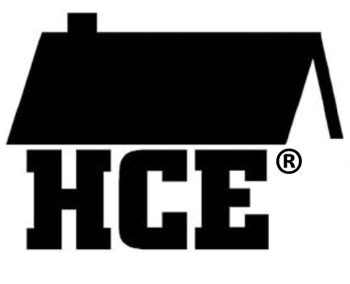

Bring Your Passion to HCE
Name_______________________
Club ________________________

Address changes
New Members
Meeting Minutes

Dues ($12) (October 31)

Make Checks out to: SCC HCE

Please mail or contact:

Phoebe Shourds
401 State Road 65,
River Falls, WI 54022
pnpaulson@yahoo.com
715-821-1606 Cell

Mission Statement:
“HCE Working Together Can Create Positive Change.
“Let’s Continue to Make it Happen”.

NOTES
_____________________________________________________________________________________________________________________________________________________________________________________________________________________________________________________________________________________________________________________________________
WAHCE Member’s Pledge

- I will treat others in a respectful manner.
- I will assume the best of others.
- I will listen and make an effort to understand and respect other’s point of view.
- I will accept assignment(s) with an open mind, a willingness to learn, and be mindful of deadlines.
- I will be dependable, recognizing the commitment and responsibility to my volunteer assignment(s).
- I will speak and act in a way that does not demean or offend others.
- I will be respectful of our leadership.

Club Organization
President
Vice President
Secretary
Treasurer

Club Member | Phone | Birthday

Suggested Order of Business

Creed
Pledge
Roll Call

Business Meeting
- Secretary Report
- Treasurer Report

Reports (Marketing, Membership, Cultural Arts, International, Bookworms, Scholarship)

Old Business

New Business

Any Other Business

Project presentation for the month (Optional)

Prayer
Record Education Program Activities
Send copy of meeting minutes to:
Phoebe Shourds – 401 State Road 65
River Falls, WI 54022
Or email to: pnpaulson@yahoo.com
jccroes@amerytel.net

Update Subscriptions
($10.00) _____ One Year or
($18.00) _____ Two Years
______ New Subscriber
______ Renewal UPDATE

Name _________________________________________

County _______________________________________

Address ______________________________________

City __________________________________________

State __________

Zip_______________ +4 ___________

Check ______; Check Number __________

Cash __________

Date __________

Please make check payable to: WAHCE, Inc.
Mail subscription and payment to:
Marcelline Protheroe, Update Editor
N6131 22nd Drive
Wild Rose, WI 54984
State / District Officers:
State President— Phoebe Shourds, 401 State Hwy 65, River Falls, WI 54022 - 715-821-1606 – pnpaulson@yahoo.com
State Treasurer—Lori Chipman, 970 County Road A, Grand Marsh 53936 715-741-1073 lchipman11@gmail.com
State Membership— Sheryl Smith, 927 Amy Drive, Holmen 54636 - 608-317-2411 Smith.sheryl1947@gmail.com
State Secretary—Louise Dahlke 5781 S. Cty Road T, Denmark 53910 – 920-362-4756 lddahlke50@gmail.com
Dist. Director NW— Bobbie Shaffer 6405 County Road A, Webster 54893, 715-866-4344 (H) 715-791-4510 (C) Bertashaffer@gmail.com
Dist. Membership— Phoebe
Dist. Marketing— Roberta
Dist. Secretary—Kristy Sand, 963 85th Ave, Cty Rd H, Amery 54001 715-554-1349 kcants@hotmail.com
Dist. Treasurer—Vicki Maves E4990 920th Ave, Boyceville, 54725 715-632-2486 vickimaves@yahoo.com
Dist. Cultural Arts—Margaret Breisch, N6820 639th St, Menomonie 54751 715-235-7124 breischm@gmail.com
Dist. Intl—Jean Kelley 1429 130th Ave., New Richmond, 54017 612-229-5591 jeanekelley07@hotmail.com

WI Bookworms Coordinator—Elaine Villeneuve N6977 430th St., Menomonie 54751; 715-235-3656 vilnev@wwt.net

Update Editor—Marcelline Protheroe N6134 22nd Drive; Wild Rose 54984; 920-622-3959 marceproth@gmail.com

 | Extension  St. Croix County WI

Kari-Weiss—Area Extension Director 715-410-4346C
Heather Vierling - 4-H Program Educator 715-531-1938

St. Croix County UW-Extension
Agricultural Service and Education Center
1960 8th
Ave., Suite 140
Baldwin, WI 54002
Phone: 715-531-1930 Fax: 715-684-2666
https://stcroix.extension.wisc.edu/
Hours: 8:00 am—4:30 pm

January 2026

Meeting Date: _______________

Hostess: ___________________

Place: ___________________________

Time : _______________

Contribution Hours: _________________________

Contribution Dollars: ________________________

Date | Event | Time | Location
1 | UPDATE Britelites
13 | Exec Board Mtg | 2 – 3:30 | Ag Center

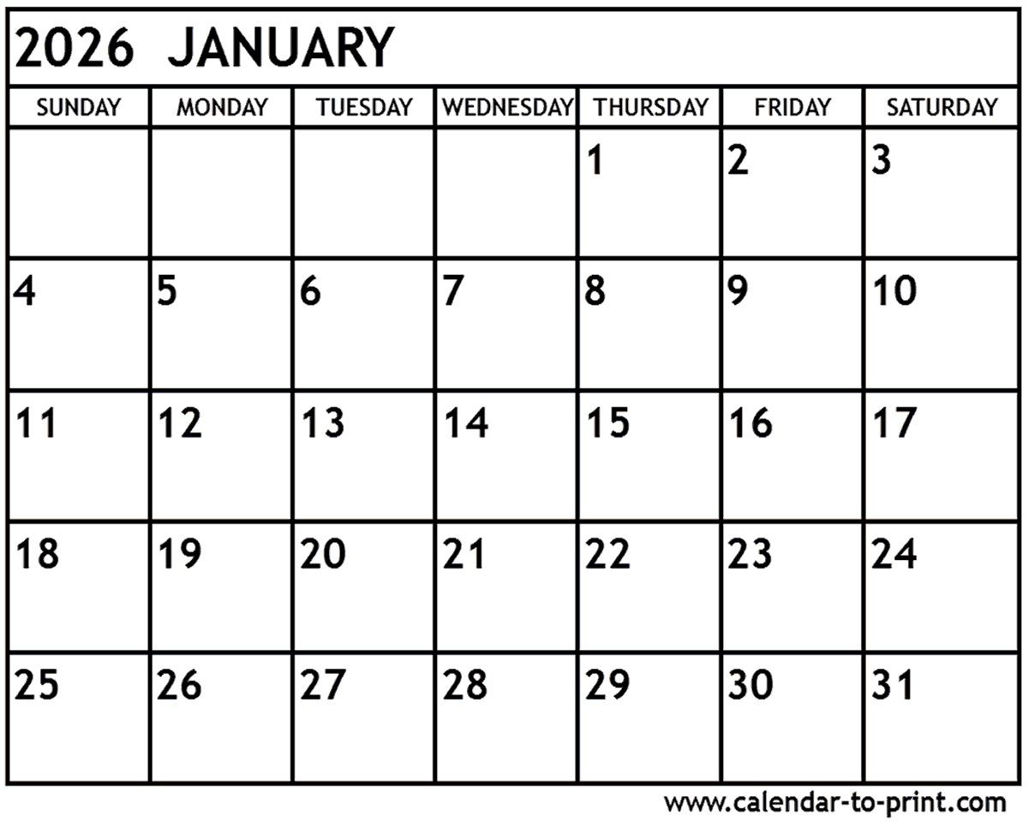
St. Croix County Executive Board Members
President: Char Croes – 2264 200th St., Deer Park, 54007 715-410-9147 jccroes@amerytel.net

President-Elect,

Secretary, Stephany Bourdon, 1870 80th St., Balsam Lake, 54810; 715-245-3266; tombourdon@gmail.com

Treasurer/Membership/FB, Phoebe Shourds, 401 State Road 65, River Falls, 54022; 715-821-1606© pnpaulson@yahoo.com

Scholarship, Deanna Johnson, 1312B 146th Ave, New Richmond, 54017, 715-246-7148 – Deannaleejohnson@yahoo.com

Marketing (County and District),

Cultural Arts, Lois Burri/Char Croes, 2215 Hwy 46, Deer Park, 54007; 715-269-5145; jccroes@amerytel.net

Membership, See Phoebe Above

International and International WNP,
Jean Kelley (W N/P), 1429 130th Ave., New Richmond, 54017; 612-229-5591 or 715-246-5591 (H); jeanekelley07@hotmail.com

Melodee Sortedahl W356 N 2nd Apt 5, Spring Valley 54767 715-690-5132 msortedahl@yahoo.com

Wisconsin Bookworms/Readers Coordinators,
Mary Hampton, 158 County Road NN, Spring Valley, 54767 715-690-9559
Jeanne Niccum, 1400 9th Ave. Baldwin 54002 715-684-2630

Fair Representative, Phoebe Shourds (see above)

St. Croix County Clubs & Presidents or Contacts

Deer Park—Char Croes 2264 200th Street, Deer Park, WI 54007 715-410-9147 (3rd Thursday at 6:30 pm)

Honey Doers—Jeanne Niccum 1400 9th Ave, Baldwin 54002 715-684-2630 (2nd Monday at 1:30 pm)

Pleasant Grove— Roxanne Lund, 390 Cty Rd BB, Woodville, 54028 715-684-3936 (3rd Thursday at 1:00pm – (no mtgs Dec, Jan or Feb)

Warren – Stephany Bourdon, 1870 80th St. Balsam Lake, 54810 (no set date) 715-245-3266

Woods ‘n Hills—President; Liz Doyone, 1623 Namekagon St #35, Hudson, 54016; 715-386-3470 (2nd Wednesday at 1:00 pm)

* For individual member’s contact information, please contact Phoebe Shourds 715-821-1606

Jennifer Raddatz 715-541-2384 | Phoebe Shourds 715-821-1606
Kay Walsh – 715-247-3423 | Jean Kelley 715-246-5591
Carol Keller – 715-386-8244 | Junalee Hoganson 715-265-4701
Cindy Long – 715-952-4255

February 2026

Meeting Date: _______________

Hostess: ___________________

Place: ___________________________

Time : _______________

Discussion Topic: _______________________

Date | Event | Time | Location
12 | Cabin Fever  Potluck | 11:30 | Ag Center Local Food Needs

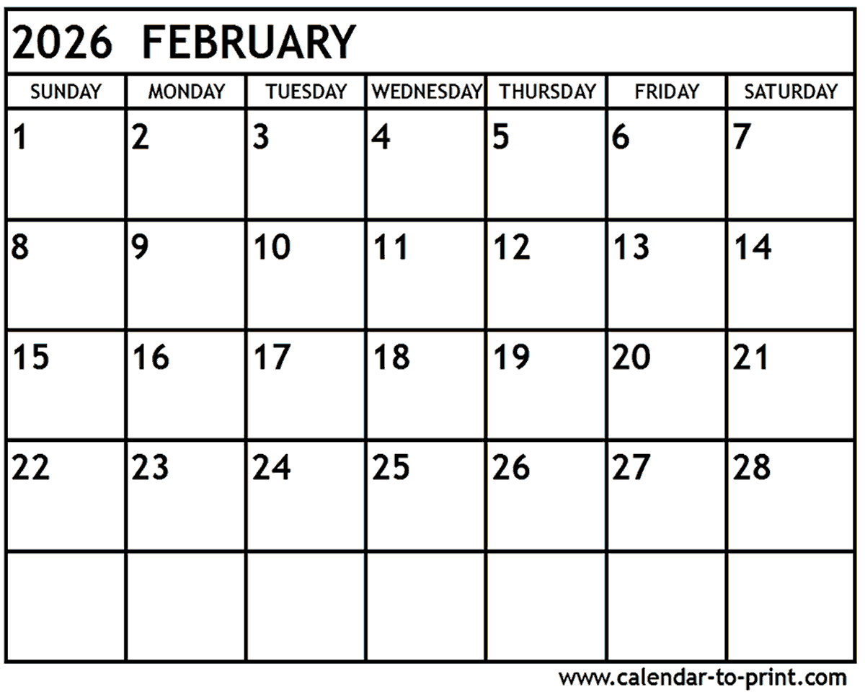

March 2026

Meeting Date: __________________________

Hostess: ________________________________

Place: ___________________________________

Time : ___________________________________

Discussion Topic: _______________________

Date | Event | Time | Location
10 | Executive Board Mtg | 2 pm | Ag Center

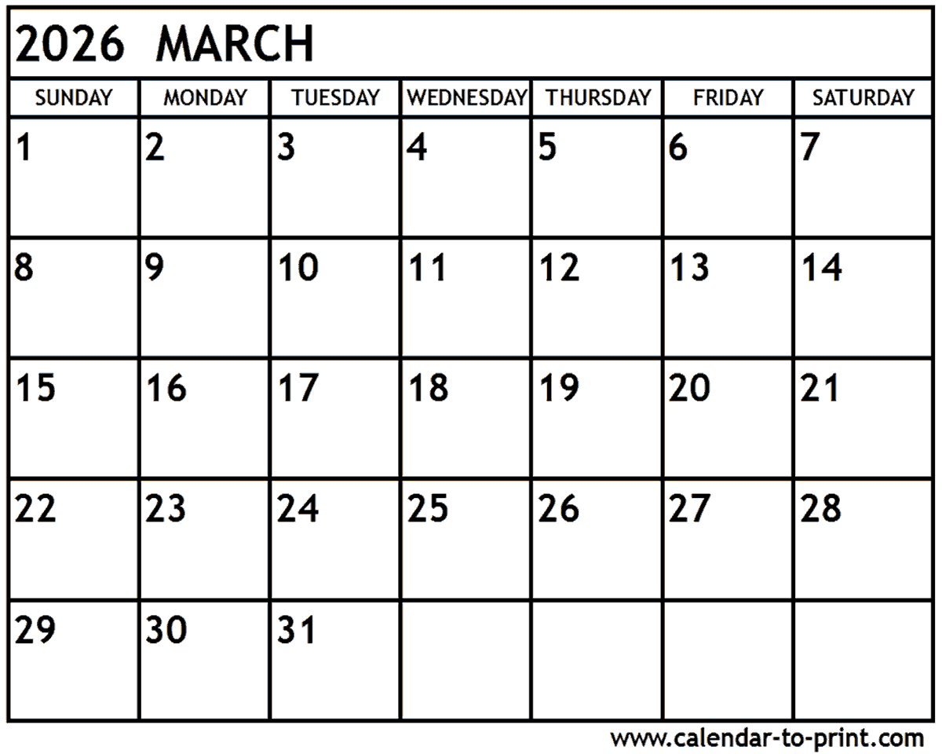

December 2026

Meeting Date: _______________

Hostess: ___________________

Place: ___________________________

Time : _______________

Discussion Topic: _______________________

Date | Event | Time | Location
 | Holiday Fair | 9-1 | Deer Park

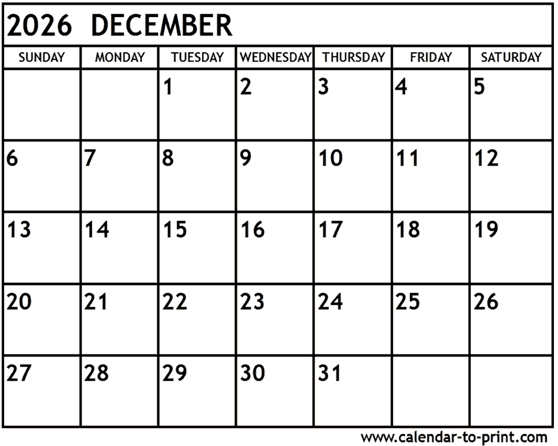`
November 2026

Meeting Date: _______________

Hostess: ___________________

Place: ___________________________
Time : _______________

Discussion Topic: _______________________

Date | Event | Time | Location
2 | Fall Council/Intl | 11:15 am | Deer Park Comm Ctr  Call 715-269-5301 to reserve by Oct 30.
10 | Potluck/Planning | 12:00 | Ag Center  Not Election Day

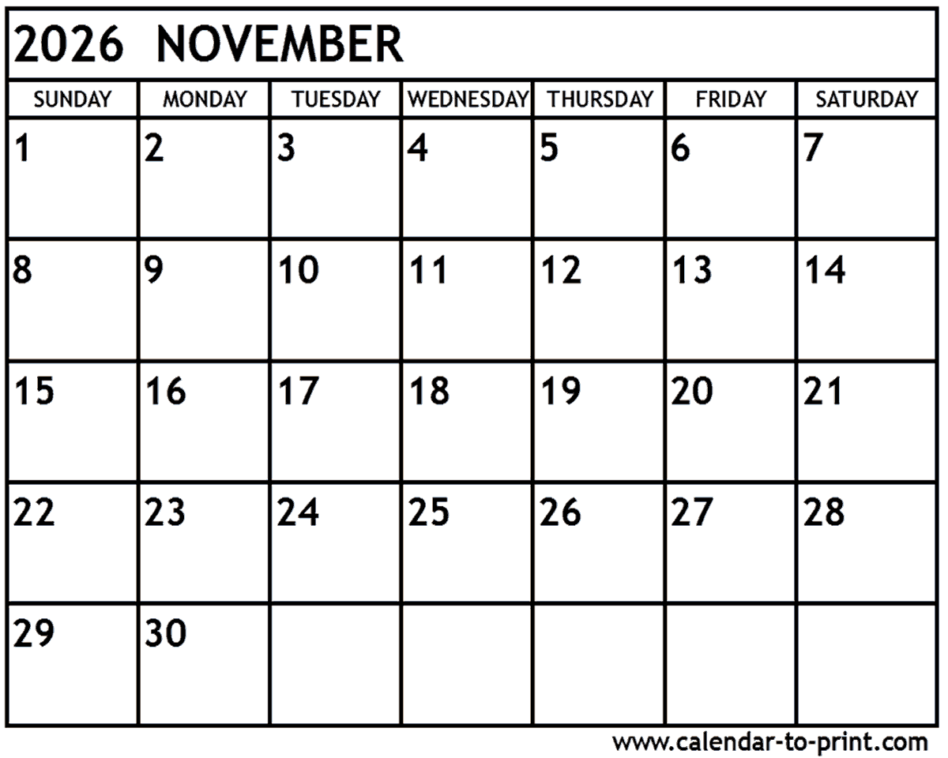
April 2026

Meeting Date: _______________

Hostess: ___________________

Place: ___________________________
Time : _______________

Discussion Topic: _______________________

Date | Event | Time | Location
24 | Spring Council  Meeting | 9:30 | Hammond Town Hall
TBD | Spring District  Meeting | 11am | Bayfield/Douglas Hosting

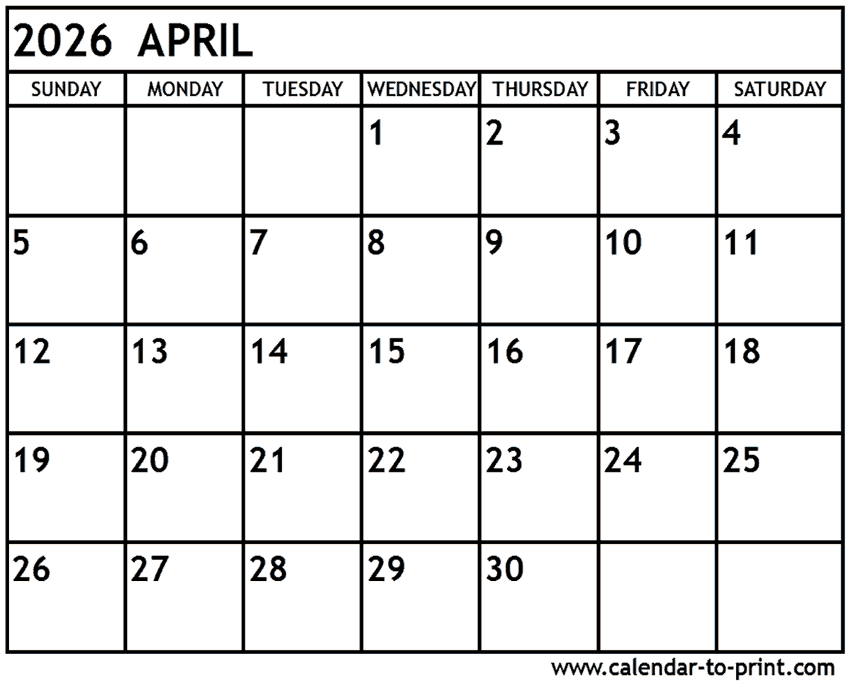
May 2026

Meeting Date: _______________

Hostess: ___________________

Place: ___________________________

Time : _______________
Discussion Topic: __________________________

Date | Event | Time | Location
12 | Executive Board | 10 pm | Fairground Bring own Lunch

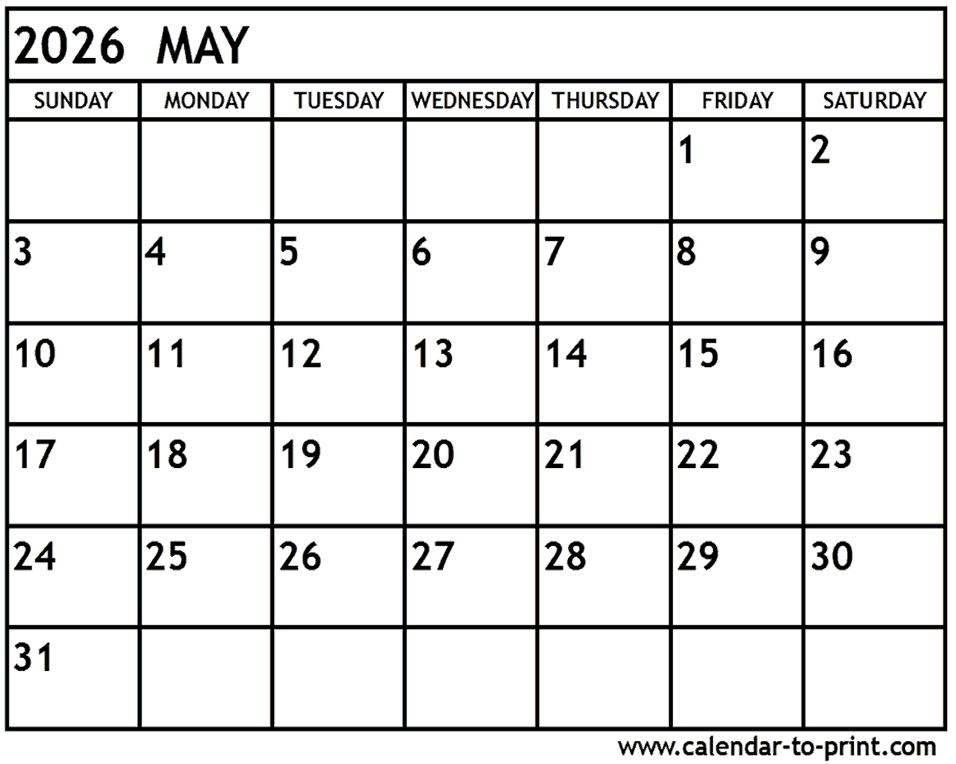

October 2026

Meeting Date: _______________

Hostess: ___________________

Place: ___________________________

Time : _______________
Discussion Topic: _______________________

Date | Event | Time | Location
TBD | Fall District | 2:pm | Zoom
30 | Fall Council/Intl  November 2 | 11:30am | Reserve by Oct 30th  715-269-5301
31 | Dues due to Treasurer | $12 | Provide list of members, Officer Positions

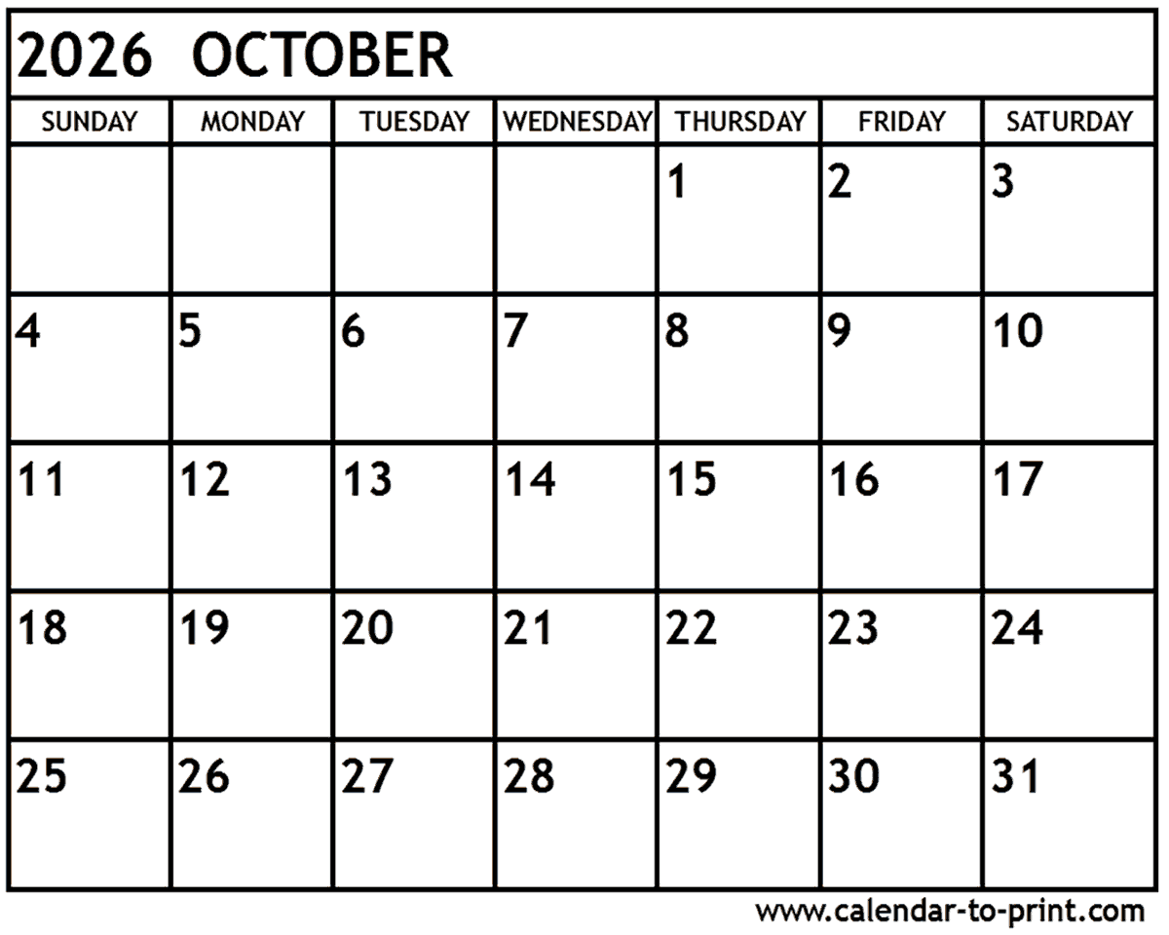
September 2026

Meeting Date: _______________

Hostess: ___________________

Place: ___________________________

Time : _______________

Discussion Topic: _______________________

Date | Event | Time | Location
8 | Executive Board | 2 pm | Ag Center
20-23 | State Conference |  | The Lismore – Eau Claire

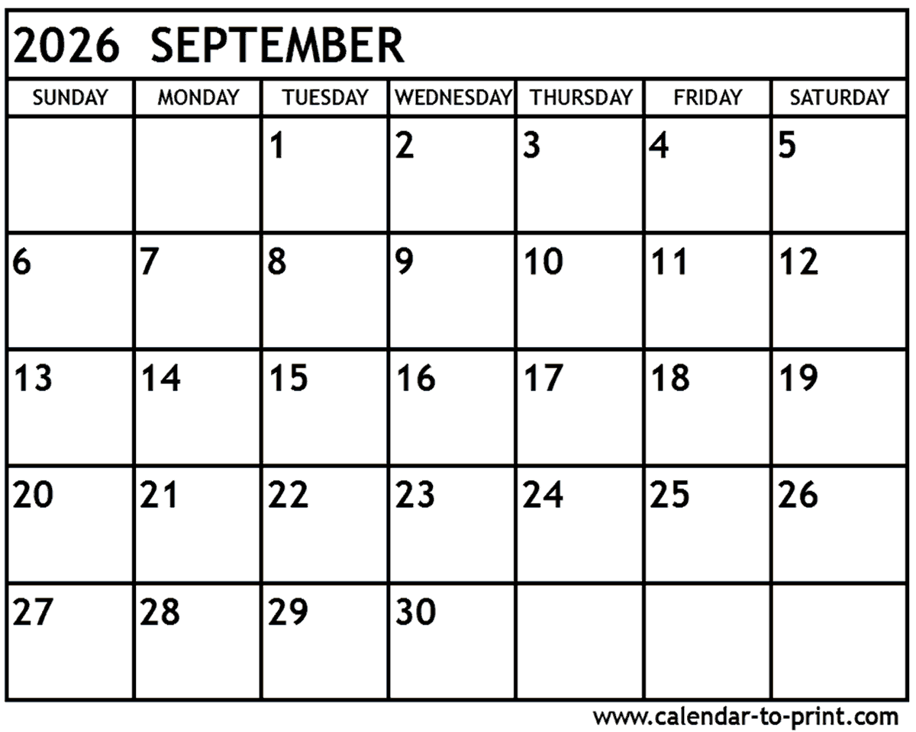

June 2026

Meeting Date: _______________

Hostess: ___________________

Place: ___________________________

Time : _______________

Discussion Topic: _______________________

Date | Event | Time | Location
24 | Meet and Greet  Anita Setter Honey Bee Farm (After Lunch) | 12:00 | Star Prairie Friendly Bar -

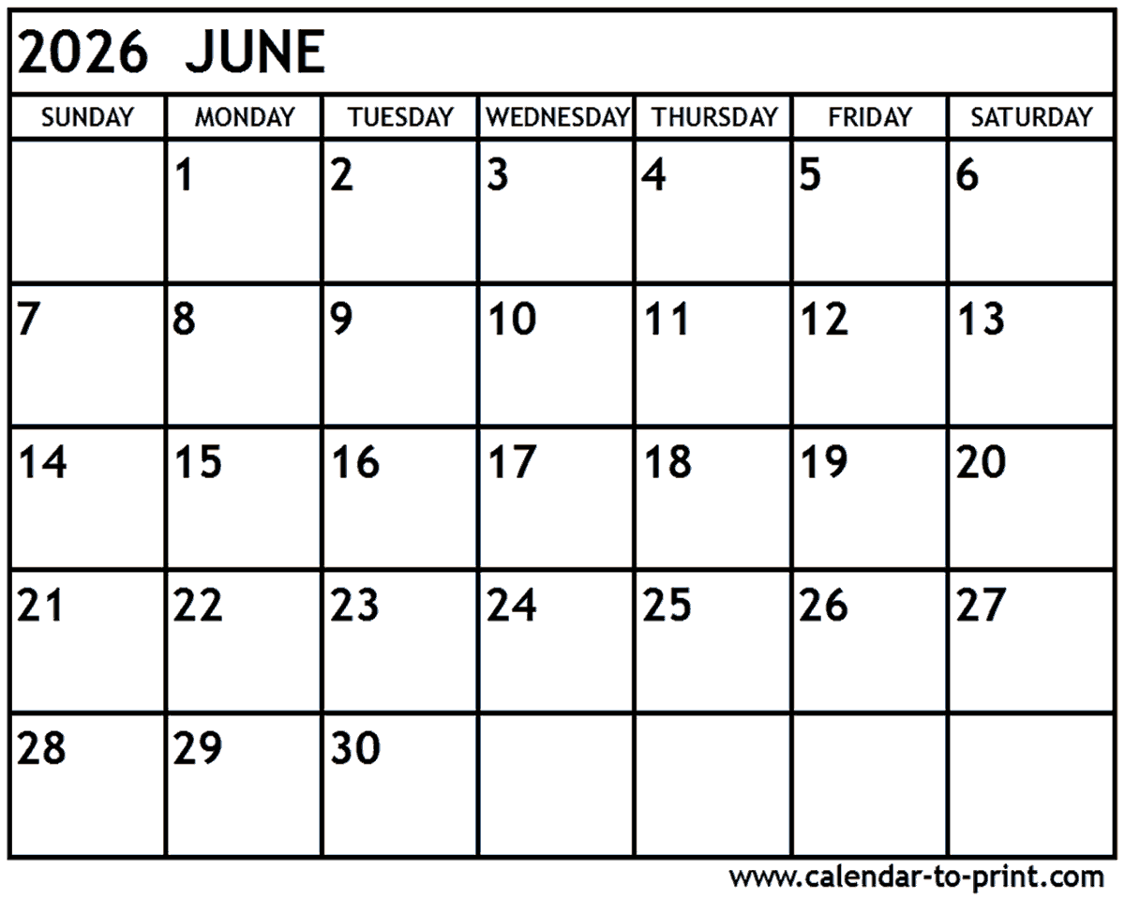

July 2026

Meeting Date: _______________

Hostess: ___________________

Place: ___________________________
Time : _______________

Discussion Topic: _______________________

Date | Event | Time | Location
7 | Executive Board | 10 am | Fair Grounds – Bring Own Lunch
14-16 | NVON |  | Wisc Dells, WI
15-19 | St. Croix Cty Fair | 9 – 9 | Glenwood City

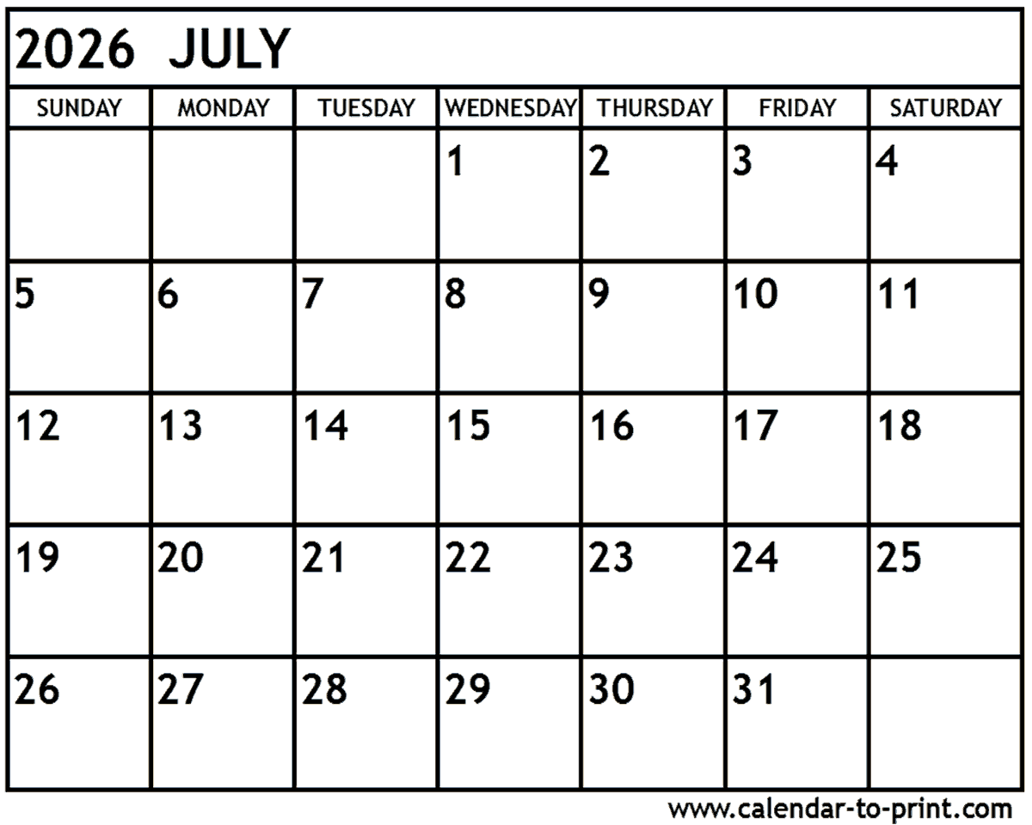
August 2026

Meeting Date: _______________

Hostess: ___________________

Place: ___________________________
Time : _______________

Discussion Topic: _______________________

Date | Event | Time | Location
1 | Cultural Arts Registrations Sheets Due
26 | Meet & Greet | 11:30 | TBD

