2026 WAHCE Annual Business Meeting & Conference
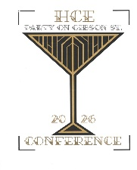
September 21-23, 2026
The Lismore Hotel Doubletree by Hilton
333 Gibson Street Eau Claire, WI

DISPLAY SPACE REQUEST FORM

Please reserve 4’ of table space for our county display:
County: Contact Person:
Address:
Telephone: E-Mail:
Description of Display

Mail this completed request form by 1st Class Mail postmarked no later than August 1 to:
Donna Zarovy, Vice President of Program
6207 203rd Avenue, Bristol, WI 53104
262-945-7502 – zarovy@frontier.com

Displays may be set up on either Sunday evening September 20 or Monday morning September 21 and need to be removed at the conclusion of the banquet on
Tuesday evening.
Please return this form or e-mail me before the due date above so that adequate table space is provided for displays.
Your space allowance is 4’ which is ½ of an 8’ table.
(Please adhere to these guidelines.)
Updated May 2026

