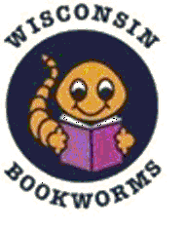
2026 - 2027 Wisconsin Bookworms
Book List
The review team has been reviewing a list of books to choose from for the 2026-2027 school year. Thank you to the members who reviewed the suggested books.
The following books have been selected for reading for the 2026-2027 school year. The number of books each county reads varies so the cost of each book is included.

Sounds On the Farm by Alex Ives $ 1.95
Count on Fish by Rebecca Tree 2.25
Biscuit Plays Ball 2.10
The Caring Me I Want to Be by Mary DiPalermo and Emma Randall 2.00
The Little Pigs (Spanish) 2.25
The First Day of Kindergarten by Tish Rebe 2.00
What Will We Build Today by Katherine Durgin-Bruce 2.35
Pete the Cat and the Perfect Pizza Party 3.98

Seven Books $14.90
Eight Books $18.88

Counties either ordered seven or eight book sets to read.
There will be a Wisconsin Bookworms Workshop at the WAHCE Annual Business Meeting and Conference in September 2026. Books will be introduced and the book plates and labels will be distributed. If a Bookworms County Chair is not available to attend, please assign a representative to pick up your materials.
No Bookworms program in your county – contact Jean Brew to start a new program or return to the reading program.
Jean Brew
Wisconsin Bookworms Chair

